IT Policy and Netiquette

In the group discussion on IT Policy and Netiquette held on 20 and 21st Jan 2000, the following points were discussed:

- Current use of computer facilities
- Further expansion of the facilities
- Bulletin boards
- Newsgroup services
- Paperless office
- Computerization of library
- Authentication and security issues
- Development of web pages
- IT policy of NML
- Code of conduct for users
- Printing service
- Breakdown of network and internet facilities
- Support for computer-related problems

From the discussion, in which a large section of NML employees participated, the following major conclusions were arrived at:

- The computer and network facilities at NML have been put to important professional use in the recent past. See Appendix A for examples of such uses.
- It is necessary to extend the use of computer technology for expediting office, research and marketing practices at NML. For this task forces need to be set up to plan, implement and administer the use of such technology in certain key areas. Recommendations of task forces necessary at this point of time, along with the mandate for their operation, are given in Appendix B.
- Through the group discussion certain issues could be identified in which immediate decision are required. Appendix C lists the issues in which executive decisions are solicited.
- In order to promote the usage of computer and networking facilities at NML and provide support as and when necessary, a computer support service needs to be set up. The structure and mode of operation of such a service group that emerged from prolonged discussions on this aspect is detailed in Appendix D.

Prepared by the panel for the Group Discussion
Head, CAP
Director, NML
Appendix A
SOME ILLUSTRATIVE EXAMPLES OF INTERNET USAGES AT NML
(We are sure many more could be added to this list)

# | Name | Type of Use∗ | Details | When used
1. | S C Maulik | Purchase:  price of an instrument | To determine sp. gr. of baryte, Le-Chatelier Flask is used internationally. It is not available in India. By using Yahoo we could get address of a supplier in UK. We got a budgetary quotation from them thro' e-mail. On the basis of the quotation, order has been placed | Dec '99
2. | S C Maulik | Purchase: budgetary quotation | One of our customer wanted to us to indicate the price of Wet High Intensity Magnetic Separator m/c (1.5 t capacity). Through Yahoo we could get the address of supplier in Germany and against our enquiry, they have forwarded the information | Feb. 2K
3. | S.Tarafder | Research: specific information | Wanted information on constraint effects in ductile fracture, which is an area in which we are pursuing sponsored and in-house research. Used Copernic2000 to search the Web. Obtained about 42 hits that are relevant. Obtained information such as: which groups are currently working in this area, what are some of their current publications in the area, Ph.D. theses submitted in the general area recently, pictures and diagrams of equipment, specimen, fixtures used for investigation. Following links, a large amount of information on fracture mechanics in general could also be obtained, including some of the software available (downloads available in a few cases). | Jan 2K
4. | Rakesh Kumar | Presentation: specific information | I was asked to make a short and colourful presentation on Heap Leaching using bacteria. Time available was 48 hrs. There was hardly any information available on the subject in library. Through net search on the subject using Yahoo and Altavista, I was able collect relevant information and put it in the form of a presentation. | Feb.’99
5. | Rakesh Kumar | Presentation: specific information | I was seeking information on Recycling of Metallurgical Waste, especially suited for sharing with the studentsζ during the CSIR programme on promotion of youth leadership. Web pages of British Recycling Association, Bureau of International Recycling, CANMET provided the much-needed pictures and text to prepare a presentation. | Sept. 99
6. | Sanjay Sondhi | Research: software download | The software (Java Structure Viewer) enables you to View & Manipulate various pre-defined & user defined atomic arrangements:  - To view the atomic configuration around a stressed crack-tip.  - To show crystal structures of various metals and other compounds to visiting students as they were interested in crystallography | July 99
7. | Rakesh Kumar | Symposium: receipt of manuscript, downloading software | - During the Indo Russian Microsymposium on Non-ferrous Extractive Metallurgy in the New Millennium, we received good number of manuscript from Russia as well as India through net mail. This saved lot of time and was particularly very useful since the size of our incoming mail on ren.nic is limited.  - In a particular instance, the manuscript came in compressed mode (*.arj format) for which we did not have the required software to decompress. We were able to download the required software from internet and handle the file. This saved us enormous time and efforts. | Oct.99  Dec.99
8. | Byomkesh Dash | System Administration: software updates | The internet is used for updating software like NAV and others | Routinely
9. | Vinod Kumar  &  T.K.Thomas | Purchase: Search for supplier | For 1999-2000 P-15 Modernisation procurement, we searched the net and located address of suppliers for Hot Isostatic Press | Oct.99
10. | T.K.Thomas | Purchase: Insurance claim | E-mailed to AIG, Europe, for processing of insurance claim for Logitech, UK, which arrived in a damaged condition. Successful in getting Rs.1.38 Lakh as compensation. | Dec.99

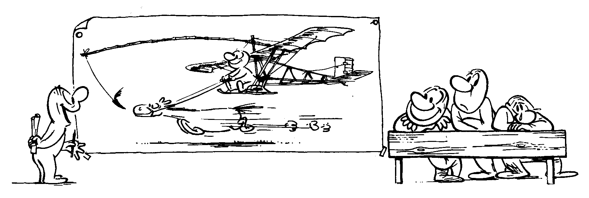
Appendix B

TASK FORCES RECOMMENDED TO BE CONSTITUTED

- Task Force on Web Page development

- Mandate:
- To undertake the development, posting and updation of NML home page in the Internet, including its links.
- To ensure that Intranet web pages of divisions and services are developed and maintained, and logically linked.
- Constitution:
Three to four persons with aptitude/Interest/experience in web authoring HTML programming, web page designing lead by webmaster.
- Linkages:
- DCRs for division-level or service specific Intranet web page development and maintenance.
- Professional web page designer under contract.

- Task force on paperless office practice

- Mandate:
To evolve the use of electronic forms in NML, including retrieval and submission of such forms electronically and supporting status query operations.
Initially, efforts to be made to make available in the Intranet forms that are commonly used, so that hard copies may be retrieved and used. In the next phase, electronic submission of the forms to be introduced for areas where authentication and security are not serious issues, for e.g. Service division and units, IRM etc. Finally, after authenticity verification software become available and accepable, forms that require authorization, or must be routed through multiple authorizers, can be brought under the preview of electronic processing.
- Constitution:
Three to four persons including representatives from Establishment, Store & Purchase and IRM.
- Linkages:
- DCRs for conversion of divisional forms into electronic version.
- Professionals under contract for developing advanced electronic forms and processing software.


- Task force for computerization of library

- Mandate:
- To develop an interactive computer catalogue for all accessions to NML library that accessible over the network.
- To computerize library lending and borrowing operations.
- To develop efficient system for retrieval of archival material via the Internet, including e-journals and e-books.
- Constitution:
Three to four persons lead by Librarian.
- Linkages:
- Volunteers for data input to computer catalogue.
- Professionals under contract for development of appropriate database software.

- Task force for newsgroup/bulletin board services

- Mandate:
- To plan and implement the various categories of services that are to be provided.
- To act as moderator/editor for information posted at such electronic form.
- Constitution:
Three to four persons so that individual moderators can be provided for the various categories of services.

- Task force for computer support

- Mandate:
- To improve the computer awareness of NML personnel through training.
- To prepare and update documentation relating to computer usage and troubleshooting.
- To provide support for computer related problems.
- Constitution:
Essentially the apex of the computer support traingle, as given in Appendix D Comprises of such persons in NML who have the best expertise in hardware and software.
- Linkages:
- DCRs for disseminating awareness and providing working level support.
- HRD unit for formal training programs.
- Professionals on contract for providing hardware support when necessary.

Appendix C

EXECUTIVE DECISIONS SOLICITED

- The E-mail system has become an important channel for communication at NML. However the service is frequently not available primarily due to failure of the P&T line connecting the e-mail modem to the NIC node. Since NML subscribes to a number of P&T lines, some of which are always working, one of the working lines may be temporarily connected to the e-mail modem to keep the email system alive. A decision in this regard is required to be taken and responsibilities assigned.

- The centralized photo copying system at NML has proved to be successful. A centralized printing system may be set up along the same lines, taking advantage of the lab-wide networking that is already in place. Such a service should be contracted out, and include high quality printing and color printing also. Decision to set up a centralized printing service is solicited and necessary orders issued.


Appendix D

PLAN FOR COMPUTER SUPPORT

Utilization of computer and networking facilities at NML has increased in recent times due to expansion of the system. It is foreseen that in the near future the use of computers would increase further due to planned advances in the services and facilities provided. In this scenario, a computer support service is necessary in order to promote efficient use of computers. Such a support service should perform the following functions:
- Improve computer awareness in NML through HRD initiatives.
- Generate documentation on computer usage and troubleshooting for base level users.
- Provide support for software and hardware problems of users.
Through prolonged discussion on this issue, the structure of an envisaged computer support service that emerged is schematically shown below.
DCRs
EXPERTS
Users
DOCUMENTATION
TRAINING
CONTRACT

The computer support service should have a three-tier pyramid structure. At the topmost level are the experts who constitute the task force for computer support (see Appendix B). This level plans the activities of the support service and are the ultimate referral authority. The experts provide support to the users at the base level via the divisional computer representatives (DCRs). The DCR concept has recently been implemented, and found to be successful. The DCRs would be responsible for interacting with users in their own domains, enhancing their computer awareness and providing solutions to their problems. Problems will be referred to the expert group only after DCRs fail to provide solutions. All the users of computer facilities form an integral part of the support structure. Users will be encouraged to solve their own problems taking the help of DCRs and expert group.

The computer support service is envisaged to operate against a background of three layers: documentation, training and contract support. Over a period of time, documentation on system setting, software usage and troubleshooting will be built up by the expert group. The documents will be available over the network and as hardcopies in the library. User will be encouraged to refer to the documents for self-help and awareness development. Training on various aspects of computer operation and maintenance will be provided in conjunction with the HRD unit to DCRs and users. The experts would also undergo training on advanced aspects at professional outlets. Contract arrangements with professional service providers would be established so that, on recommendation of the expert group, they may redress hardware and systems problems that are unsolvable internally, on payment basis

It is envisaged that the computer support service would, in course of time, evolve and enforce within the usergroup a minimum code of conduct, and essential ethics and etiquettes of using the net.

.

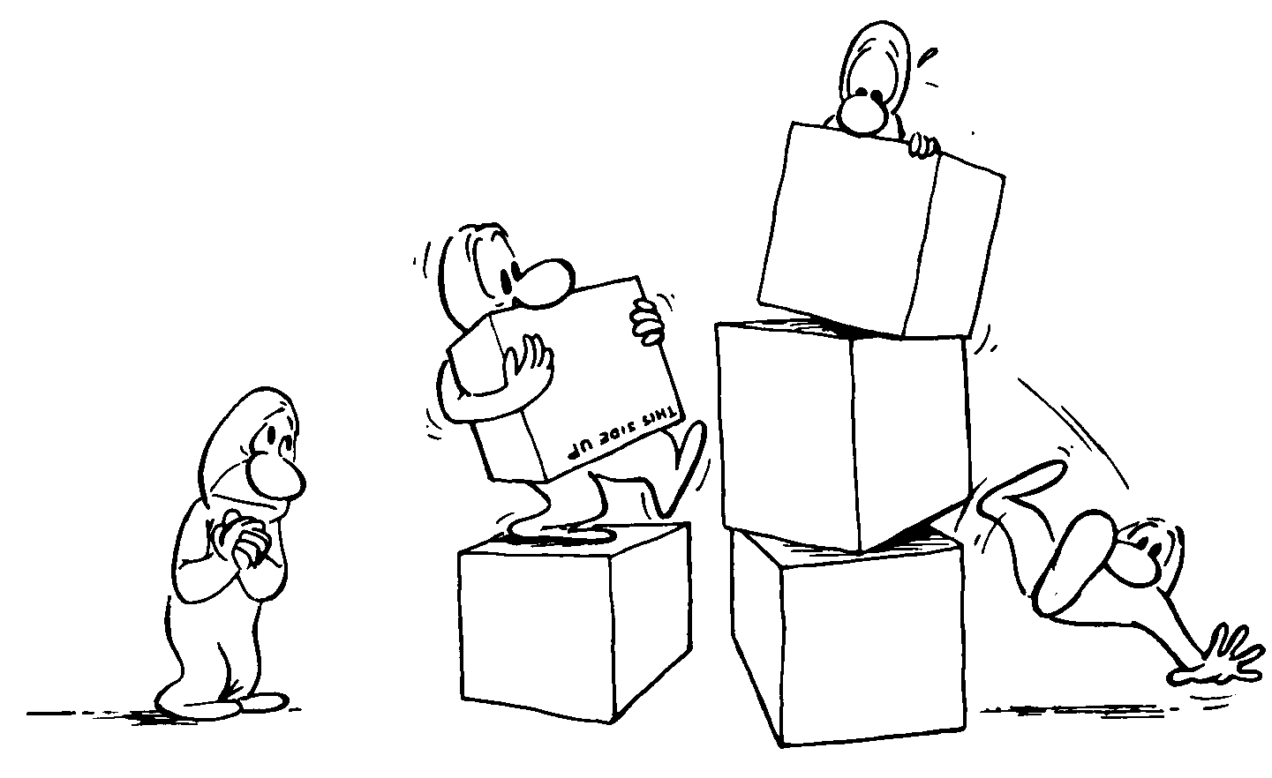

 Research/Administration/ Purchase etc., alongwith specific nature of use.
 When we prepare our web page, it will be nice to have a section for school children at various levels

